Київський фаховий коледж зв’язку

**ЗВІТ ПО ВИКОНАННЮ**

**ЛАБОРАТОРНОЇ РОБОТИ №1**

з дисципліни: «Операційні системи»

**Тема: “** **Acquaintance with the operating environment of virtual machines with the same features**

**Linux operating system”**

Виконали студенти

групи КСМ 13а

Засенко Олександр

Дзюбенко Дмитро

Сторожук Костянтин

Перевірив викладач

Сушанова В.С.

Київ 2023

**Мета роботи:**

1. Знайомство з гіпервізорами різного типу, віртуалізацією при роботі з операційними системами.

2. Знайомство з основними видами сучасних ОС, короткий огляд їх можливостей.

**Матеріальне забезпечення занять**

1. ЕОМ типу IBM PC.

2. ОС сімейства Windows (Windows 7).

3. Віртуальна машина – Virtual Box (Oracle).

4. Операційна система GNU/Linux – CentOS.

5. Сайт мережевої академії Cisco netacad.com та його онлайн курси по Linux

**Завдання для попередньої підготовки**

***Готував матеріал студент Засенко Олександр***

Прочитайте короткі теоретичні відомості до лабораторної роботи та зробіть невеличкий словник базових англійських термінів з питань класифікації ОС.

|  |  |
| --- | --- |
| Термін англійською | Термін українською |
| **Operating System** | Операційна система |
| **Single-tasking operating system** | Однозадачна операційна система |
| **Multitasking operating system** | Багатозадачна операційна система |
| **Monopoly operating system** | Монопольна операційна система |
| **Cross-platform operating system** | Крос-платформена операційна система |
| **Virtual operating system** | Віртуальна операційна система |
| **Network operating system** | Мережева операційна система |
| **Embedded operating system** | Вбудована операційна система |
| **Windows operating systems** | **Віконна операційна система**: |

1. ***Прочитавши матеріал з коротких теоретичних відомостей дайте відповіді на наступні питання:***

***1.1. Охарактеризуйте поняття «гіпервізор». Які бувають їх типи?***

A hypervisor, is a software or hardware layer that enables the virtualization of physical computer hardware, allowing multiple virtual machines (VMs) or operating systems to run on a single physical host.

There are two main types of hypervisors:

1. **Type 1 Hypervisor (Bare-Metal Hypervisor):**

* A Type 1 hypervisor runs directly on the physical hardware without the need for a host operating system.
* It provides a high level of performance and efficiency because it has direct access to the underlying hardware.
* Examples of Type 1 hypervisors include VMware vSphere/ESXi, Microsoft Hyper-V (when installed in standalone mode without Windows Server), and Xen.

1. Type 2 Hypervisor (Hosted Hypervisor):

* A Type 2 hypervisor runs on top of a host operating system.
* It is typically used for development, testing, or situations where performance is not critical.
* Since it relies on the host OS for resource management, it may introduce some overhead.
* Examples of Type 2 hypervisors include Oracle VirtualBox, VMware Workstation, and VMware Fusion (for macOS).

***1.2 Перерахуйте основні компоненти та можливості гіпервізорів KVM***

KVM (Kernel-based Virtual Machine) is an open-source hypervisor that is integrated into the Linux kernel. It allows you to create and manage virtual machines (VMs) on a Linux host. Here are the main components and capabilities of KVM:

**Components:**

1. Linux Kernel Module (KVM Module): The KVM module is a loadable kernel module that provides the core virtualization functionality. It enables the Linux kernel to act as a hypervisor.
2. QEMU: QEMU (Quick Emulator) is an emulator that works in conjunction with KVM to provide full virtualization capabilities. It helps manage the hardware-level virtualization and emulates the hardware for VMs.
3. Libvirt: libvirt is an open-source API and management tool that simplifies the management of various virtualization technologies, including KVM. It provides a common interface for managing VMs and storage.
4. Virtual Machine Manager (Virt-Manager): Virt-Manager is a desktop application that offers a graphical user interface (GUI) for managing VMs running on KVM. It allows you to create, configure, and control VMs with ease.
5. Kernel-based Virtual Machine (KVM): The KVM component of KVM is a kernel module that provides hardware-assisted virtualization capabilities. It leverages hardware features like Intel VT-x and AMD-V to improve performance and security.

**Capabilities:**

1. **Hardware Virtualization:** KVM utilizes hardware virtualization extensions (Intel VT-x and AMD-V) to achieve near-native performance for VMs. This allows VMs to directly access CPU resources, resulting in improved efficiency.
2. **Support for Multiple Guest Operating Systems:** KVM can run a wide range of guest operating systems, including Linux, Windows, macOS, and others. It supports both 32-bit and 64-bit guest OSes.
3. **Live Migration:** KVM supports live migration, which allows you to move running VMs from one physical host to another with minimal downtime. This is crucial for load balancing and system maintenance.
4. **Snapshot and Cloning:** You can create snapshots of VMs at specific points in time, allowing you to revert to previous states if needed. KVM also supports cloning, making it easy to replicate VM configurations.
5. **Resource Management:** KVM provides resource management features, including CPU and memory allocation, to ensure fair sharing of physical resources among VMs.
6. **Security Isolation:** VMs are isolated from each other, enhancing security by preventing one VM from accessing another's memory or data.
7. **High Availability:** KVM can be configured in high-availability clusters, ensuring VMs remain available even in the event of hardware failures.
8. **Nested Virtualization:** KVM supports nested virtualization, allowing you to run VMs inside VMs. This is useful for testing and development environments.
9. **Integration with Management Tools:** KVM can be managed using various tools, including Virt-Manager, libvirt, and command-line interfaces (such as virsh).

KVM is a powerful and versatile open-source hypervisor that is widely used in the industry due to its performance, scalability, and flexibility. It is commonly used in data centers and cloud environments to create and manage virtualized infrastructure.

***1.3 Вивчіть матеріали онлайн-курсу “NDG Linux Essentials” від академії Cisco:***

***- Chapter 1 - Introduction to Linux***

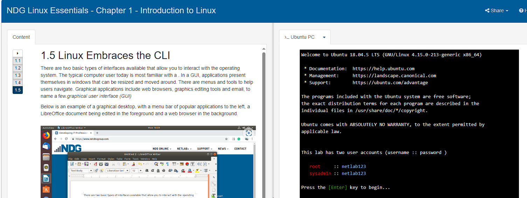

***- Chapter 2 - Operating Systems***

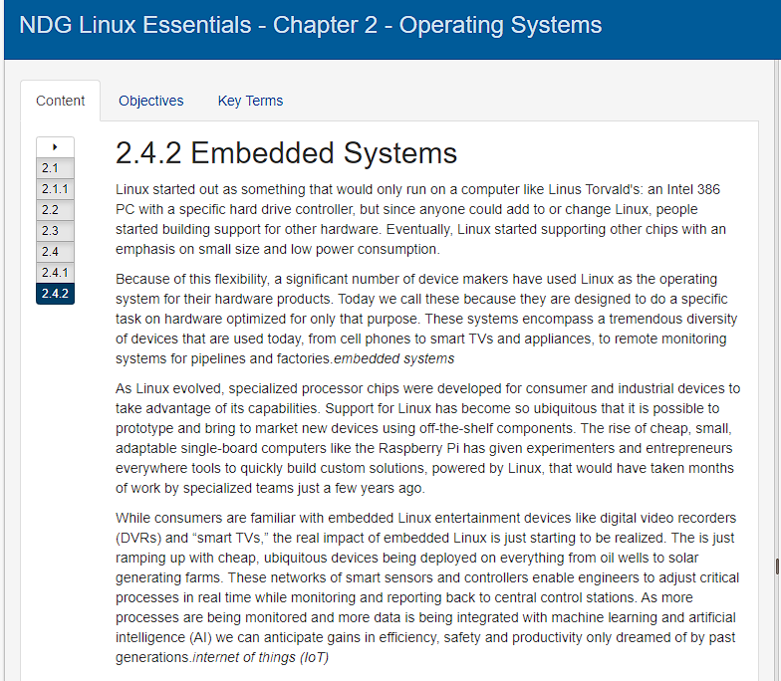

***1.4 Пройдіть тестування у курсі NDG Linux Essentials за такими темами:***

**Chapter 02 Exam**

***Готував матеріал студент Засенко Олександр***

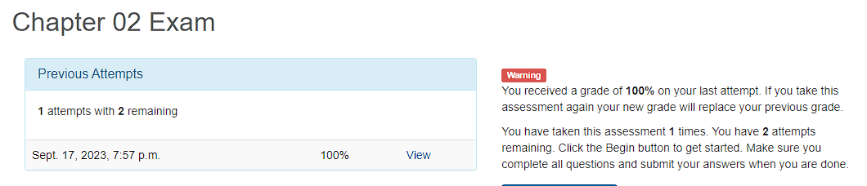

**Хід роботи**

***Готував матеріал студент Dziubenko***

1. Робота в графічному режимі в ОС сімейства Linux:.

Нами були переглянуті такі відео**:**

1.1. GNU/Linux. Базові відомості.

Доступ: https://www.youtube.com/watch?v=k4AKMLS2Ac8

1.2. The Shell (Linux)

Доступ: https://drive.google.com/open?id=0B0PV0_SM0LoDSVNPWUVRdUxaN2s

1.3. Огляд графічних оболонок Linux

Доступ: <https://www.youtube.com/watch?v=lEGplwLXZ78>

2. Питання.

2.1. Етапи для розгортання операційної системи на базі віртуальної машини VirtualBox.

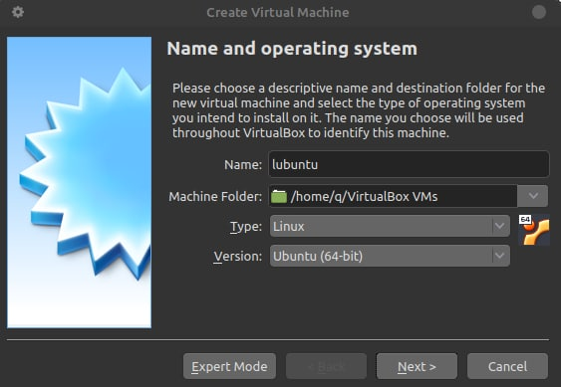

To install the linux system, you will need to download the system from the developers' website in .iso format. You can learn more about the choice of distribution on thematic sites and choose xfce/kde or another. In our case, we use linux lubuntu.

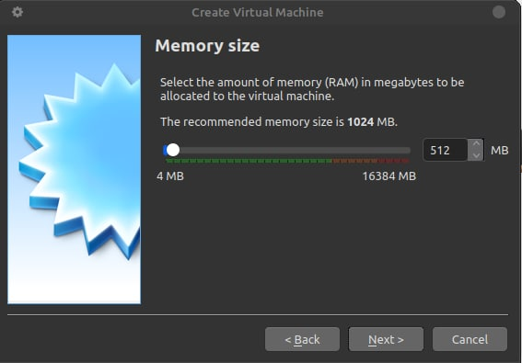

Any Linux-based system is lighter and faster than Windows or macOS. These platforms have grown so much that they require at least 8 GB of RAM for comfortable operation and powerful modern chips.

The kernel itself is not at all demanding, and most of the components are not either. There is no excess of tracking and analytics technologies, so everything works faster by default, and a 2006 model PC is enough for a comfortable life.

But Linux, like its components, is also evolving and getting heavier. Ubuntu itself will not work properly on a device with less than 4 GB of RAM. That's why we need lightweight distributions that are still trying to please users with outdated hardware.

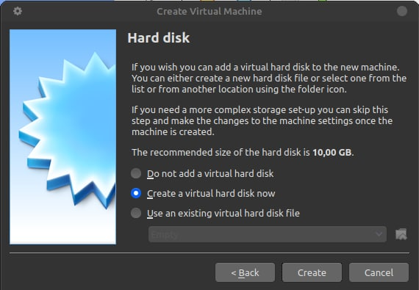

The lubuntu system was personally used in everyday life to perform some kind of work by the participants of this lab. In the future, screenshots will be taken at difficult areas during the installation of the system. Then click next, next until we reach the moment when a new system is created in the list of the VitualBox program.

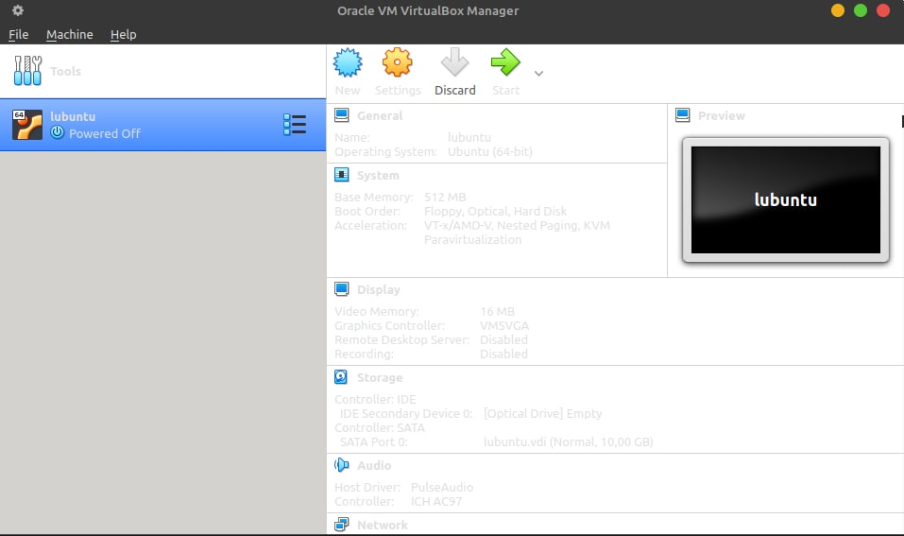

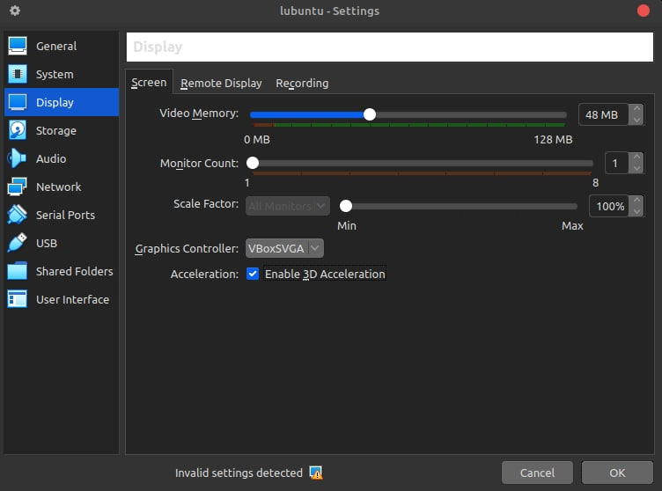

In order to use the operating system comfortably, let's tweak the settings a bit. Select the video memory (the best option is 48 or more). Turn on VBoxSVGA and enable 3D acceleration, as shown in the picture.

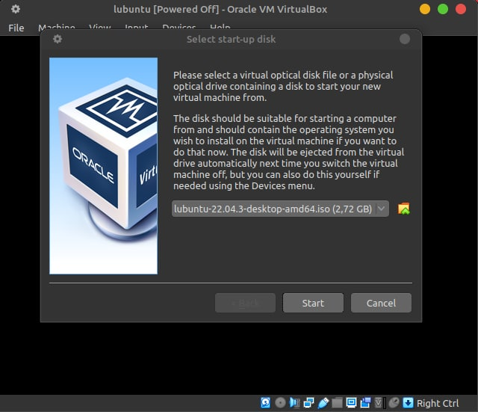

At the moment of starting the virtual machine, we will be asked to choose a boot image for our machine. From the list, we select the system, as previously mentioned, in iso format.

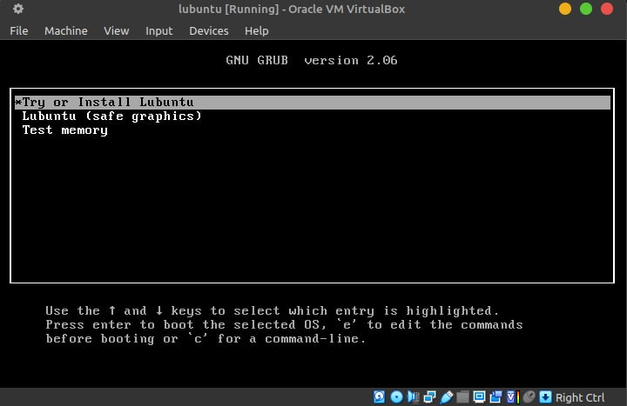

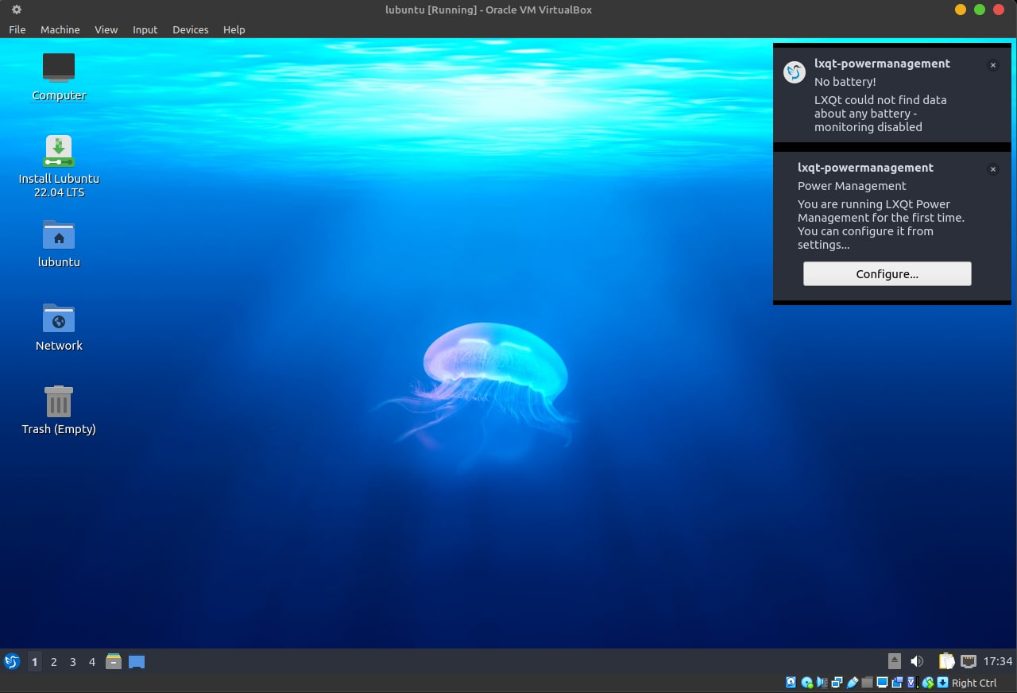

If you get a kernei panic error, most often this error is caused by a low amount of RAM.

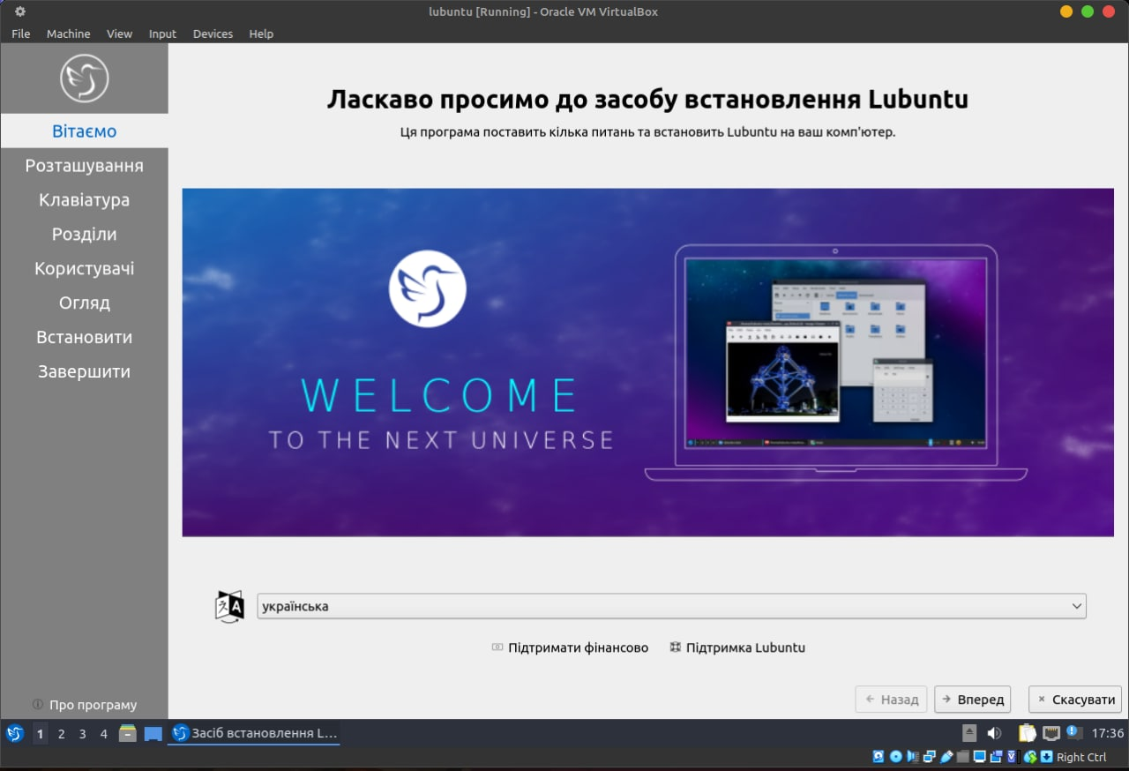

When installing the system, everything is intuitive if you have at least once installed systems such as Windows or Linux on the main machine.

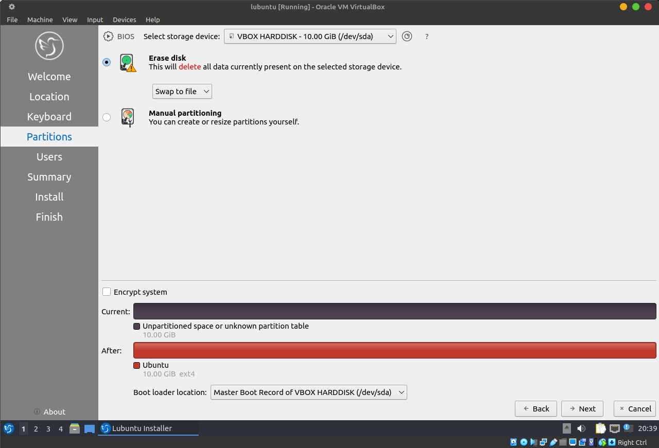

For new users, it is recommended to choose the option with a complete disk wipe to install the system. If you already know how to install, then edit the disk as you want.

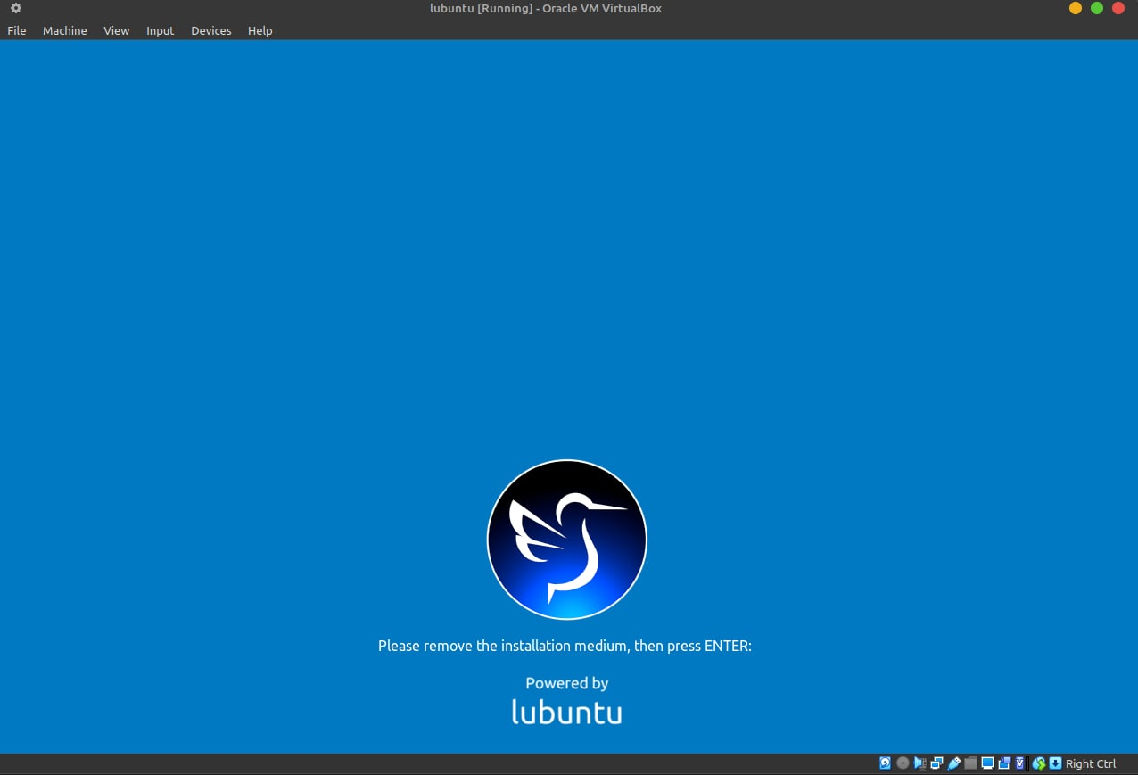

After waiting for the system to load on the virtual machine and rebooting it, you will see this window. This means that the Linux system has been successfully installed. Press Enter and use a ready system running Linux.

* 1. Yes, there are such limitations, and they are quite significant. Some necessary programs can support only one of the 32bit - x86/64bit - x64 variants. Also, when installing the system, the processor may not support one of the above options.
  2. The main steps in installing CentOS in text mode:
* Loading from media
* Select a language
* Choose a location and time
* Setting up the network
* Select the type of installation
* Disk settings: Choose how to manage disks
* Choose a password for the root user
* Installing packages
* Finish the setup
* Finish the installation
* Boot the installed system
  1. To install GNOME and KDE desktops on CentOS, if it is already installed in text mode, you need to run the following commands:

For GNOME:

Install the GNOME GUI packages and the "systemctl" configuration variable to switch to graphical mode:

* sudo yum groupinstall "Server with GUI"
* sudo systemctl set-default graphical.target
* sudo systemctl isolate graphical.target

For KDE:

Install the KDE GUI packages and the "systemctl" configuration variable to switch to graphical mode:

* sudo yum groupinstall "KDE Plasma Workspaces"
* sudo systemctl set-default graphical.target
* sudo systemctl isolate graphical.target
  1. Xfce is a lightweight desktop environment for Unix-like operating systems. The goal is to be fast and resource-efficient, while being attractive and easy to use.

Xfce embodies the traditional UNIX philosophy of modularity and reusability. Xfce consists of a number of interconnected components that can be used in other projects if desired. These components include:

* window manager;
* application launcher;
* display manager;
* user session management and energy management manager;
* file manager - Thunar;
* web browser - Midori

FVWM - F Virtual Window Manager (F is not officially used anymore) is a virtual window manager for the X Window System. Originally a derivative of twm, FVWM has evolved into a powerful environment for Unix-like systems with the ability to customize.

**Відповіді на контрольні запитання**

***Готував матеріал студент Storozhuk***

* + - 1. Type 1 and Type 2 hypervisors are two different approaches to virtualization, and they have differences in architecture and application.

A type 1 hypervisor (direct or native) runs on the direct hardware level of the physical server, bypassing the need to install an operating system. It gets direct access to server resources.

A type 2 hypervisor (guest or hosted) is installed as an additional layer in the operating system of the host server and runs as a regular software application in the operating system.

A type 1 hypervisor is generally considered more reliable because it runs independently of the operating system and has fewer potential points of failure.

A type 2 hypervisor may have a higher risk of vulnerabilities because it is based on the operating system, which can affect its stability.

A type 1 hypervisor usually has higher performance because it runs on the direct hardware level and has direct access to server resources.

A Type 2 hypervisor may be less efficient because of the additional layer of virtualization that comes with using an operating system, which can lead to a decrease in efficiency compared to Type 1 hypervisors.

1. The GNU General Public License is one of the most popular free software licenses, created by Richard Stallman for the GNU project. It is often abbreviated as GNU GPL or simply GPL if the context makes it clear which license is being referred to (there are many other licenses with the words "general public license" in the name).

The purpose of the GNU GPL is to grant the user the rights to copy, modify, and distribute the program and the obligation that users of all derivative programs will also receive these rights. The principle of "inheritance" of such rights is called "copyleft" (transliteration of the English "copyleft"). This term was coined by Richard Stallman. Unlike the GPL, licenses for proprietary (proprietary) software very rarely grant the user such rights and mostly try to limit them, for example, by prohibiting the restoration of the source code.

The GPL is an example of a strong copyleft license that requires all derivative works to be available under the same terms as the original. The GPL grants recipients of a computer program rights as defined by free software and uses copyleft to ensure that these rights are preserved even if the work is significantly altered or parts are added to it. This distinguishes it from permissive free software licenses, such as the BSD license or the Apache license.

1. The essence of OSS lies in the following aspects: The code of open source software is available to anyone who wants to view it. This allows information security professionals to analyze software for potential security risks and ensure its security. Open source allows developers and information security professionals to fix identified vulnerabilities without restrictions, which allows them to respond quickly to potential threats. Open source projects usually have an active community of users and developers who work together to maintain and improve the product. This helps to identify and resolve security issues.
2. A distribution is a form of software sharing.
3. A system administrator based on the Linux operating system can perform a variety of tasks, including:

Managing files and directories: Copying, moving, deleting files and directories, and granting file permissions. System monitoring: Monitor resources such as CPU, memory, disk space, and network traffic to detect anomalies and resolve performance issues. Network configuration: Setting up network interfaces, IP addresses, routing, firewall. This is a small list of what it can do. It all depends on the ability to work with Linux.

1. Android is based on the Linux kernel and uses many open-source components, but has its own superlayer of interface and applications developed by Google.
2. It is used in the Internet of Things (IoT), mobile devices, medical equipment, automotive industry, etc. Embedded Linux supports a variety of processor architectures, making it versatile for different devices. Linux is known for its stability and reliability, making it popular for embedded systems where reliability is critical.
3. You can use the systemctl command to change the Linux boot type between text and graphical modes.

For example, to boot in text mode (level 3): sudo systemctl set-default multi-user.target

To boot in graphical mode (level 5): sudo systemctl set-default graphical.target

After executing the corresponding command and rebooting the system, Linux will boot in the mode you have chosen.

CLI The command line interface allows the user to communicate with the system using commands.

GUI The Graphical User Interface allows the user to interact with the system through graphics, which includes images, icons, etc.

**Висновки**

***Готував матеріал студент Storozhuk***

In the course of the laboratory work, we studied different types of hypervisors and visualization when working with the operating system, and theoretically studied the installation of the hypervisor and the linux operating system in more detail. We gained practical skills in working with teams to work with github, installing the linux ubuntu operating system, and downloading some programs on the linux ubuntu operating system. We faced difficulties such as the problem with insufficient RAM for the operating system and insufficient disk space. There were also some problems when loading virtualbox, but we managed to solve them.